Caselet
ProcessGenius AI – The Compliance Complexity
A Generative AI Opportunity in Enterprise Process Optimization
Company Overview
Axiom Solutions is a well-established IT services and consulting firm based in New York, specializing in streamlining complex business processes for large enterprises, particularly in regulated industries like finance and pharmaceuticals. Their core offering involves designing and implementing custom workflow automation and compliance management systems. While their solutions are robust, a growing pain point for their clients is the sheer complexity and manual effort involved in documenting, updating, and auditing these intricate processes to meet ever-changing regulatory requirements.
The Challenge
It was a tense Monday morning at Axiom Solutions. Mark Johnson, Head of Consulting Services, was facing a major client pushback. "Our clients are complaining that generating and updating compliance documentation for new processes takes months, not weeks," he stated. "We're seeing a 30% increase in 'Compliance Audit Preparation Time' for our top clients, and their 'Process Documentation Accuracy Score' is down to 7/10."
Sarah Patel, a senior Business Analyst, added, "Our BAs spend 70% of their time writing and re-writing process documents based on regulatory changes. It's tedious, prone to human error, and delays project delivery. We're talking hundreds of thousands of dollars in lost productivity and potential compliance fines for our clients."
The Spark of Innovation
Mark had recently explored advanced Generative AI capabilities for document generation. He envisioned "ProcessGenius AI": an intelligent system that could revolutionize how enterprises manage compliance and process documentation. This AI could:
- Generate detailed, compliant process documentation from high-level inputs or existing fragmented data.
- Automatically update process documents based on new regulatory changes, flagging discrepancies.
- Create natural language explanations of complex compliance clauses for non-technical users.
- Identify potential compliance gaps in existing processes and suggest improvements.
The Review Meeting
At the quarterly strategic review, CEO Alex Chen was cautiously optimistic. "This sounds like a powerful tool. But what's the tangible benefit beyond 'saving time'? How does this impact our own 'Consulting Revenue Growth' or 'Client Engagement'?"
Mark responded, linking "ProcessGenius AI" directly to Axiom's core business: "Our value proposition is delivering efficiency and reducing risk. This AI allows us to deliver process solutions faster, with higher accuracy, and significantly reduce our clients' compliance burden. This translates to higher client satisfaction, increased project scope, and opens up new recurring revenue streams for 'AI-powered compliance maintenance' services."
The Decision Point
Alex approved a 4-month pilot with three enterprise clients in the finance sector. "Prove that this AI dramatically reduces the documentation burden and tangibly improves compliance accuracy. But we need strict guardrails—the AI must never misinterpret a regulation, and human oversight must be absolute for critical outputs."
Mark left the meeting energized. The next four months would determine if Generative AI could truly transform enterprise compliance and solidify Axiom's market leadership.

AI Prompt - Working Backwards Document
#### CONTEXT & OBJECTIVE ####
I need to draft an internal press release for a new product idea
using Amazon's Working Backwards methodology. The objective is to
clearly articulate the customer problem, the product's solution,
and the benefits to the customer, as if the product is already
launched.

#### STYLE ####
Act as an experienced Product Manager with a deep understanding of
customer obsession and product innovation.

#### TONE ####
Analytical, customer-centric, and forward-looking.

#### AUDIENCE ####
Internal stakeholders including engineering, design, marketing,
and leadership teams.

#### RESPONSE ####
A complete internal press release (headline, summary, problem,
solution, customer quote, how to get started, call to action,
guardrails & success metrics, and internal FAQs) that is concise,
impactful, and clear, with no jargon.

#### STEPS ####
1. Headline: Create a compelling headline announcing the new
product and its primary benefit, incorporating <Product_Name>.
2. Summary: Provide a concise summary of the product, who
<Target_Customer> is, and the main <Core_Problem> it solves.
3. Problem: Describe the <Core_Problem> in detail for the
<Target_Customer>.
4. Solution: Explain how the <Product_Solution> directly
addresses this problem with a clear, benefit-oriented description,
weaving in the <Key_Benefits>.
5. Customer Quote: Invent a realistic quote from a delighted
<Target_Customer>, crafted to the <Elements_of_Value>,
highlighting a key benefit.
6. How to Get Started: Briefly explain how a customer would begin
using the product.
7. Call to Action: State the internal next steps for the team
based on the <Internal_CTA> and <Pilot_Success_Criteria>.
8. Guardrails & Success Metrics: Explicitly state the
<Guardrails> the solution must respect, and how
<Pilot_Success_Criteria> will be measured at the end of the pilot.
9. Internal FAQs: Generate 3-5 internal FAQs that anticipate
common questions from engineering, design, and business
stakeholders, including the <Anticipated_Internal_Questions>.

#### INPUT VARIABLES ####

<Product_Name>
"ProcessGenius AI"
</Product_Name>

<Target_Customer>
"large enterprise clients in regulated industries (finance and
pharmaceuticals) who rely on Axiom Solutions for workflow
automation and compliance management, particularly their Business
Analysts and Compliance/Audit teams"
</Target_Customer>

<Core_Problem>
"documenting, updating, and auditing complex business processes
to meet ever-changing regulatory requirements takes months instead
of weeks; Compliance Audit Preparation Time is up 30%, Process
Documentation Accuracy Score has fallen to 7/10, and BAs spend 70%
of their time manually writing and re-writing process documents —
a tedious, error-prone drag that delays project delivery and risks
compliance fines"
</Core_Problem>

<Product_Solution>
"An intelligent Generative AI system, ProcessGenius AI, embedded
in Axiom's consulting workflow, that generates detailed compliant
process documentation from high-level inputs or fragmented data,
automatically updates existing documents when regulations change
(flagging discrepancies), translates complex compliance clauses
into plain language for non-technical stakeholders, and proactively
identifies compliance gaps with suggested fixes"
</Product_Solution>

<Key_Benefits>
"Compliance documentation that used to take months now takes
weeks, freeing BA time for higher-value advisory work",
"Documentation accuracy improves and compliance risk/audit
exposure drops, protecting clients from fines",
"Non-technical stakeholders can finally understand their own
compliance obligations without waiting on a BA to translate them",
"Axiom can spot compliance gaps proactively instead of reactively
during an audit"
</Key_Benefits>

<Elements_of_Value>
"Risk Reduction", "Time Savings", "Accuracy", "Clarity for
non-experts"
</Elements_of_Value>

<Internal_CTA>
"launch the 4-month pilot with the three approved finance-sector
enterprise clients"
</Internal_CTA>

<Guardrails>
"AI must never misinterpret or auto-apply a regulation without
human review", "human oversight must be absolute — all critical
outputs require sign-off from a compliance-certified BA before
client delivery", "AI-flagged compliance gaps are recommendations
only, never auto-implemented changes"
</Guardrails>

<Pilot_Success_Criteria>
"measurable reduction in Compliance Audit Preparation Time (from
the current 30% increase)", "Process Documentation Accuracy Score
improves meaningfully from the current 7/10", "zero critical
compliance misinterpretations across the pilot", "BA time
reallocated from documentation rework to higher-value advisory work"
</Pilot_Success_Criteria>

<Anticipated_Internal_Questions>
"How do we guarantee the AI never misinterprets a regulation, and
what does 'human oversight' look like operationally on every
output?",
"How exactly will we measure success at the end of the 4-month
pilot — audit prep time, accuracy score, or both, and against what
baseline?",
"What happens to BA staffing/roles if documentation time drops
this much — is this positioned as augmentation or headcount
reduction, and how do we communicate that internally?"
</Anticipated_Internal_Questions>

Working Backwards Document (response from the above prompt)
https://drive.google.com/file/d/1ITpmfsbFGkeaBo451yTYdn_Tac2-JosC/view?usp=drive_link (1 pager)
INTERNAL PRESS RELEASE
ProcessGenius AI Cuts Compliance Documentation Time from Months to Weeks for Axiom Solutions' Enterprise Clients
Hyderabad — [Launch Date] — Axiom Solutions today announced ProcessGenius AI, an intelligent generative AI system embedded directly into the consulting workflow, purpose-built to help Business Analysts and Compliance/Audit teams at large enterprise clients in finance and pharmaceuticals produce accurate, audit-ready process documentation in a fraction of the time it takes today.

Summary
Large enterprise clients in regulated industries rely on Axiom Solutions to keep their business processes documented, current, and audit-ready. But regulatory change is constant, and today that means Business Analysts spend the majority of their time manually writing and rewriting documents instead of advising clients. ProcessGenius AI generates compliant process documentation from high-level inputs, automatically flags what needs updating when regulations shift, translates dense compliance language into plain English, and surfaces compliance gaps before they become audit findings — all under mandatory human review.
The Problem
Compliance documentation has become a bottleneck instead of a safeguard. Across Axiom's regulated-industry clients, three numbers tell the story:
- Compliance Audit Preparation Time is up 30%. Regulatory requirements change faster than documentation can keep pace, and audit prep has become a scramble rather than a routine.
- Process Documentation Accuracy Score has fallen to 7/10. Manual updates mean gaps, inconsistencies, and outdated references creep into the record.
- Business Analysts spend 70% of their time manually writing and rewriting process documents. This is tedious, repetitive, and error-prone work — and it's time not spent on the higher-value advisory work clients actually hired Axiom for.
The result: project delivery slows down, audit exposure goes up, and the people best positioned to advise clients on compliance strategy are stuck formatting documents instead.
The Solution
ProcessGenius AI is a generative AI system embedded in Axiom's existing consulting workflow. It:
- Generates detailed, compliant process documentation from high-level inputs or fragmented source data — turning a blank-page problem into a review-and-refine problem.
- Automatically monitors and flags documentation affected by regulatory change, so updates happen proactively instead of during a compliance scramble.
- Translates complex compliance clauses into plain language for non-technical stakeholders, so a plant manager or a product lead can understand their own obligations without waiting on a BA to interpret it for them.
- Proactively identifies compliance gaps and suggests fixes — surfacing risk before an auditor does.
Together, this means:
- Documentation that used to take months now takes weeks — freeing BA time for higher-value advisory work.
- Documentation accuracy improves and audit exposure drops, protecting clients from fines.
- Non-technical stakeholders finally understand their own compliance obligations directly.
- Axiom shifts from reactive to proactive on compliance gaps.
Customer Quote
"Before ProcessGenius AI, our compliance documentation review was the part of the audit cycle everyone dreaded — weeks of chasing down what had changed and hoping we hadn't missed anything. Now the gaps are flagged for us before the auditors ever ask the question, and our own team can actually read what they're signing off on. It's taken real risk off our books, and it's given our Axiom BA time back to actually think with us instead of just documenting for us." — Compliance Director, Axiom Solutions client (finance sector pilot participant)
How to Get Started
Clients already engaged with Axiom on workflow automation or compliance management will have ProcessGenius AI introduced by their assigned Business Analyst as part of their existing engagement — no separate onboarding or tooling required. The BA configures ProcessGenius AI against the client's existing process documentation and regulatory scope, and every output is routed through the BA for review before anything reaches the client.
Call to Action
The team will launch the 4-month pilot with the three approved finance-sector enterprise clients. Over the pilot, the team will validate the product against the guardrails and success criteria below before making a go/no-go call on broader rollout across finance and, subsequently, pharmaceuticals.
Guardrails & Success Metrics
Guardrails (non-negotiable):
- The AI must never misinterpret or auto-apply a regulation without human review.
- Human oversight is absolute: every critical output requires sign-off from a compliance-certified BA before client delivery.
- AI-flagged compliance gaps are recommendations only — never auto-implemented changes.
Pilot Success Criteria (measured at end of 4 months):
- Measurable reduction in Compliance Audit Preparation Time, against the current 30% increase baseline.
- Meaningful improvement in Process Documentation Accuracy Score, against the current 7/10 baseline.
- Zero critical compliance misinterpretations across the pilot.
- Demonstrated reallocation of BA time from documentation rework to higher-value advisory work.
Internal FAQs
Q: How do we guarantee the AI never misinterprets a regulation, and what does "human oversight" look like operationally on every output? A: Every ProcessGenius AI output — generated documentation, flagged updates, or gap recommendations — is routed to a compliance-certified BA before it reaches a client. The BA reviews against source regulatory text, not just the AI's summary, and must explicitly sign off before delivery. Nothing is auto-applied or auto-sent. This isn't a spot-check; it's a mandatory gate in the workflow.
Q: How exactly will we measure success at the end of the 4-month pilot — audit prep time, accuracy score, or both, and against what baseline? A: Both, plus two additional criteria. We'll track Compliance Audit Preparation Time and Process Documentation Accuracy Score against the current baselines (30% increase and 7/10, respectively), alongside zero critical compliance misinterpretations and evidence that BA time has shifted from rework toward advisory work. All four criteria need to show meaningful movement for the pilot to be considered a success — this isn't a single-metric decision.
Q: What happens to BA staffing/roles if documentation time drops this much — is this positioned as augmentation or headcount reduction, and how do we communicate that internally? A: This is positioned as augmentation, not reduction. The business case for ProcessGenius AI is built on reallocating BA time toward higher-value advisory work that clients are already asking for and that documentation rework currently crowds out — not reducing the number of BAs. Pilot success is explicitly measured in part by whether that time reallocation actually happens, which keeps the team accountable to the augmentation framing rather than letting it become a headcount conversation after the fact.
Q: Who owns ProcessGenius AI outputs if something goes wrong post-launch — Axiom or the client? A: Given the mandatory human-review guardrail, the compliance-certified BA who signs off is the accountable party for anything delivered to a client. This keeps liability aligned with the existing model of BA-owned deliverables — ProcessGenius AI is a drafting and flagging tool inside that accountability chain, not a replacement for it.
Q: Does this require new infrastructure or client-side integration to work? A: No. ProcessGenius AI is embedded in Axiom's existing consulting workflow and configured by the assigned BA against the client's existing documentation and regulatory scope. There's no separate client onboarding or new tooling required to start the pilot.

AI Prompt - Personas

Starter Prompt

Create 3 detailed, distinct personas for an <AI Product Idea> that I want to
target these <players> with these pain points <pain-points>.

The <players> have these <key-goals> and are comfortable using software tools.
Some of the <players> are cautious about AI accuracy in a regulated context —
their trust is conditioned on strict human sign-off for anything critical, not
general AI skepticism.

Each persona operates in the regulatory context <regulatory-context>, and
should be tagged as <persona-type> (internal user vs. client-facing
stakeholder) so the roles aren't conflated.

The size of the organization is not more than <num-employees> with annual
turnover of <annual-turnover>.

Be less verbose. Use bulleted points in the responses.

Use names of Personas that are representative of that group instead of a name
that suggests an individual.

<AI Product Idea>
ProcessGenius AI — an intelligent Generative AI system within Axiom Solutions'
consulting offering that generates, updates, and audits compliance/process
documentation, translates complex regulatory clauses into plain language, and
flags compliance gaps for enterprise clients in regulated industries.
</AI Product Idea>

<players>
- "Business Analysts at large finance-sector enterprises who manage process
documentation for Axiom's compliance projects"
- "Compliance & Audit Managers at large pharmaceutical-sector enterprises
responsible for regulatory sign-off on process documentation"
- "Consulting Engagement Leads at Axiom Solutions responsible for client
delivery timelines and satisfaction on compliance projects"
</players>

<pain-points>
- "compliance documentation for new processes takes months instead of weeks,
delaying project delivery"
- "up to 70% of time spent manually writing and re-writing process documents
whenever regulations change, which is tedious and error-prone"
- "Process Documentation Accuracy Score has fallen to 7/10, raising audit and
compliance-fine risk"
</pain-points>

<key-goals>
- Generate and update compliant process documentation fast enough to keep pace
with regulatory change, without sacrificing accuracy.
- Free up time currently lost to manual re-writing for higher-value advisory
and audit-prep work.
- Trust that AI-generated compliance content is accurate enough to act on, with
human sign-off preserved for anything critical.
</key-goals>

<regulatory-context>
- Finance sector: regulatory bodies akin to SEC/RBI, financial-reporting and
audit-trail requirements
- Pharmaceutical sector: regulatory bodies akin to the FDA, product/process
compliance and validation requirements
</regulatory-context>

<persona-type>
- Internal user (Axiom employee using the tool to produce client deliverables)
- Client-facing stakeholder (Axiom's client, accountable for sign-off on the
output the tool produces)
</persona-type>

<num-employees>
Large enterprise clients — 1,000+ employees (exact figure not specified in the
caselet; assumed "large enterprise" per company overview)
</num-employees>

<annual-turnover>
Not specified in the caselet — left open pending real data
</annual-turnover>

COSTARS Prompt

#### CONTEXT & OBJECTIVE
You are tasked with generating 3 distinct personas for a <AI_PRODUCT_IDEA>.
These personas must reflect realistic representations of target user groups
<TARGET_PLAYERS> who share common pain points <PAIN_POINTS> and goals
<KEY_GOALS>, operate within the regulatory context <REGULATORY_CONTEXT>, and
belong to organizations of size <NUM_EMPLOYEES> earning annual revenue
<ANNUAL_TURNOVER>. The objective is to inform customer segmentation, product
positioning, marketing messaging, and UX decisions.

#### STYLE
Assume the role of a senior UX researcher and enterprise SaaS product
strategist with over 20 years of experience designing accurate, insight-driven
user personas for regulated-industry markets—particularly compliance tech and
AI-enhanced process automation.

#### TONE
Concise, analytical, and professional. Avoid verbosity. Use structured,
bulleted descriptions to present each persona clearly.

#### AUDIENCE
The personas will be used by product designers, marketers, and developers
building or enhancing the <AI_PRODUCT_IDEA>. They are experienced in
enterprise SaaS, compliance/regtech, and early-stage user research methods.

#### RESPONSE
Generate 3 distinct personas, using persona names that represent a group or
role (e.g., "Finance BA Fatima", not an individual like "Raj"). For each
persona, use bulleted format to describe:

* Industry & Role: (e.g. <TARGET_PLAYERS>)
* Persona Type: (<PERSONA_TYPE> — internal user or client-facing stakeholder;
be explicit, since ProcessGenius serves both)
* Company Profile: (e.g., <NUM_EMPLOYEES>, <ANNUAL_TURNOVER>)
* Regulatory Context: (draw from <REGULATORY_CONTEXT>)
* Pain Points: (draw from <PAIN_POINTS>)
* Goals: (draw from <KEY_GOALS>)
* Tech Comfort & AI Trust: describe trust as conditional on human sign-off for
critical outputs, not generic AI skepticism — reflect the regulatory stakes
specific to this persona's sector

#### STEPS
1. Analyze the following variables:
* AI Product Idea: <AI_PRODUCT_IDEA>
* Target Players: <TARGET_PLAYERS>
* Pain Points: <PAIN_POINTS>
* Key Goals: <KEY_GOALS>
* Regulatory Context: <REGULATORY_CONTEXT>
* Persona Type: <PERSONA_TYPE>
* Organization Size: <NUM_EMPLOYEES>
* Annual Turnover: <ANNUAL_TURNOVER>

2. Define 3 distinct personas, one for each primary player segment.

3. For each persona:
* Use a professional persona name.
* Describe the business and role context briefly.
* Mark whether they are an internal user or client-facing stakeholder, and
don't conflate the two.
* Clearly list their pain points and goals using provided inputs.
* Tie their regulatory context to the specific pain point it drives (e.g.,
FDA validation requirements → accuracy anxiety).
* Mention their familiarity with digital tools and describe their AI trust
as conditional on human oversight, not blanket skepticism.

4. Use only bulleted lists for clarity and brevity.

5. Ensure all persona attributes are derived from or aligned with the input
variables.

#### Input Variables

<AI_PRODUCT_IDEA>
ProcessGenius AI — an intelligent Generative AI system within Axiom Solutions'
consulting offering that generates compliant process documentation, auto-updates
it when regulations change, translates complex compliance clauses into plain
language, and flags compliance gaps with suggested fixes.
</AI_PRODUCT_IDEA>

<TARGET_PLAYERS>
- Business Analysts at large finance-sector enterprises managing process
documentation on Axiom compliance projects
- Compliance & Audit Managers at large pharmaceutical-sector enterprises
responsible for regulatory sign-off
- Consulting Engagement Leads at Axiom Solutions responsible for client
delivery timelines and satisfaction
</TARGET_PLAYERS>

<PAIN_POINTS>
- Compliance documentation for new processes takes months instead of weeks
- Up to 70% of BA time consumed by manual re-writing when regulations change
- Documentation Accuracy Score has dropped to 7/10, raising audit/fine exposure
</PAIN_POINTS>

<KEY_GOALS>
- Generate and update compliant documentation fast enough to match regulatory
change velocity, without losing accuracy
- Redirect time lost to manual re-writing toward higher-value advisory and
audit-prep work
- Preserve human sign-off on anything critical while trusting AI for the
first-draft heavy lifting
</KEY_GOALS>

<REGULATORY_CONTEXT>
- Finance sector: regulatory bodies akin to SEC/RBI, financial-reporting and
audit-trail requirements
- Pharmaceutical sector: regulatory bodies akin to the FDA, product/process
compliance and validation requirements
</REGULATORY_CONTEXT>

<PERSONA_TYPE>
- Internal user (Axiom employee using the tool to produce client deliverables)
- Client-facing stakeholder (Axiom's client, accountable for sign-off on the
output the tool produces)
</PERSONA_TYPE>

<NUM_EMPLOYEES>
1,000+ (large enterprise — exact figure not specified in caselet)
</NUM_EMPLOYEES>

<ANNUAL_TURNOVER>
Not specified in the caselet
</ANNUAL_TURNOVER>

Personas
1. Finance BA Riya
- Industry & Role: Business Analyst, large finance-sector enterprise — manages process documentation on Axiom's compliance engagement
- Persona Type: Internal user (Axiom staff on client project)
- Company Profile: 1,000+ employees; annual turnover not specified
- Regulatory Context: SEC/RBI-equivalent bodies — financial-reporting and audit-trail requirements drive constant documentation churn
- Pain Points:
  - Documentation for new processes takes months, not weeks
  - Up to 70% of time lost to manual rewriting when regulations shift
  - Falling accuracy score raises audit and fine risk on her deliverables
- Goals:
  - Keep documentation pace matched to regulatory change without sacrificing accuracy
  - Reclaim time from rewriting for higher-value advisory work
- Tech Comfort & AI Trust: Comfortable with software tools; trusts AI for first-draft generation but requires sign-off on anything touching audit-trail accuracy — trust is conditional on that gate, not general AI hesitancy
2. Pharma Compliance Manager Anjali
- Industry & Role: Compliance & Audit Manager, large pharmaceutical-sector enterprise — owns regulatory sign-off on process documentation
- Persona Type: Client-facing stakeholder (accountable for sign-off on Axiom's output)
- Company Profile: 1,000+ employees; annual turnover not specified
- Regulatory Context: FDA-equivalent product/process validation requirements — a misread clause has direct compliance-fine exposure, so accuracy anxiety is sector-specific and acute
- Pain Points:
  - Falling Documentation Accuracy Score (7/10) directly raises her audit exposure
  - Slow documentation turnaround compresses her review and sign-off window
- Goals:
  - Trust that AI-generated content is accurate enough to sign off on quickly
  - Preserve her own final sign-off authority on anything critical
- Tech Comfort & AI Trust: Comfortable with digital tools; wariness is specifically about auto-applied regulatory interpretation, not AI use generally — she'll trust AI output once human sign-off is structurally guaranteed, not just promised
3. Engagement Lead Marcus
- Industry & Role: Consulting Engagement Lead, Axiom Solutions — owns client delivery timelines and satisfaction on compliance projects
- Persona Type: Internal user (Axiom staff)
- Company Profile: Manages engagements with 1,000+ employee clients; client annual turnover not specified
- Regulatory Context: Spans both SEC/RBI (finance) and FDA (pharma) engagements — regulatory delay in either sector risks his delivery SLA
- Pain Points:
  - Months-long documentation cycles blow through project timelines
  - BA time drained by rewriting limits his ability to staff higher-value advisory work
- Goals:
  - Hit delivery timelines consistently despite regulatory volatility
  - Free BA capacity to expand advisory scope and client satisfaction
- Tech Comfort & AI Trust: High tool fluency; his AI trust is tied to whether the guardrails (human sign-off, no auto-applied changes) hold up under client scrutiny — he's selling the tool's reliability to skeptical clients, so his own trust threshold is downstream of theirs

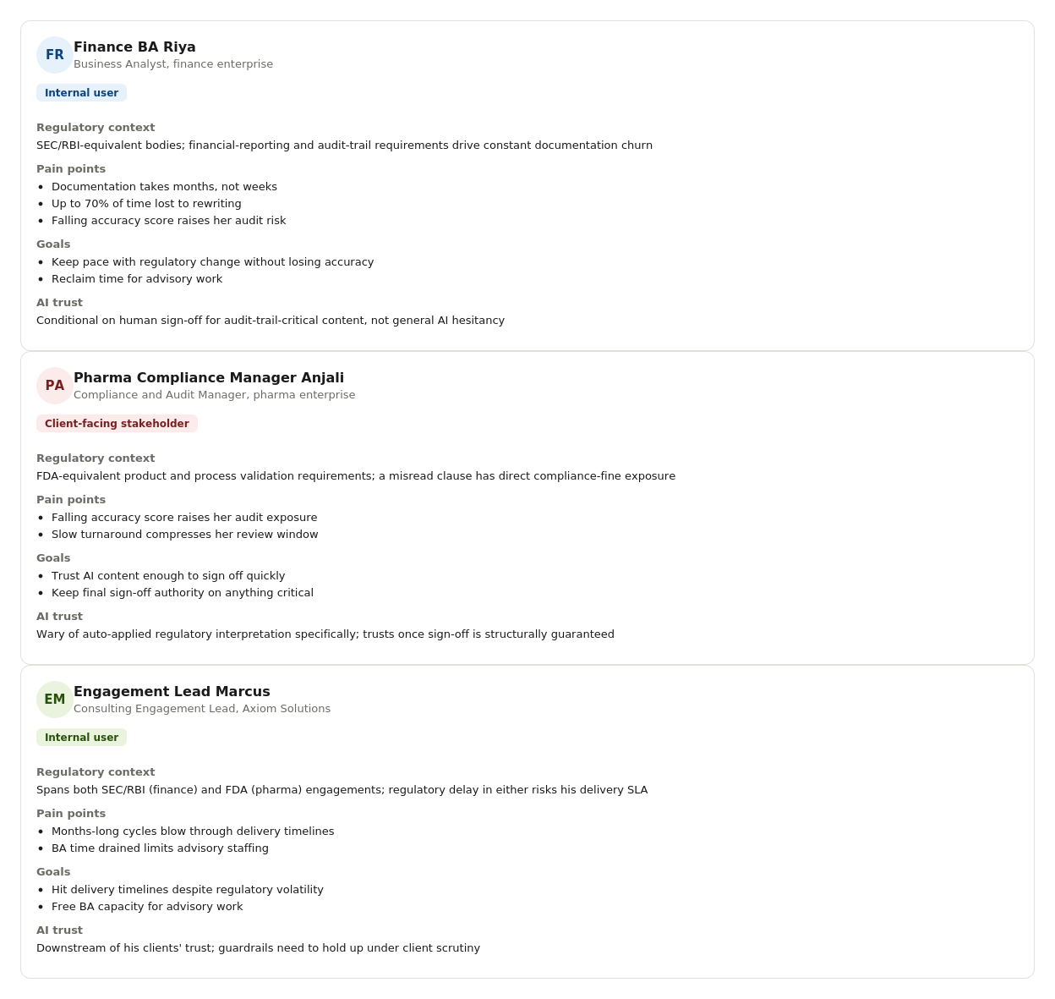

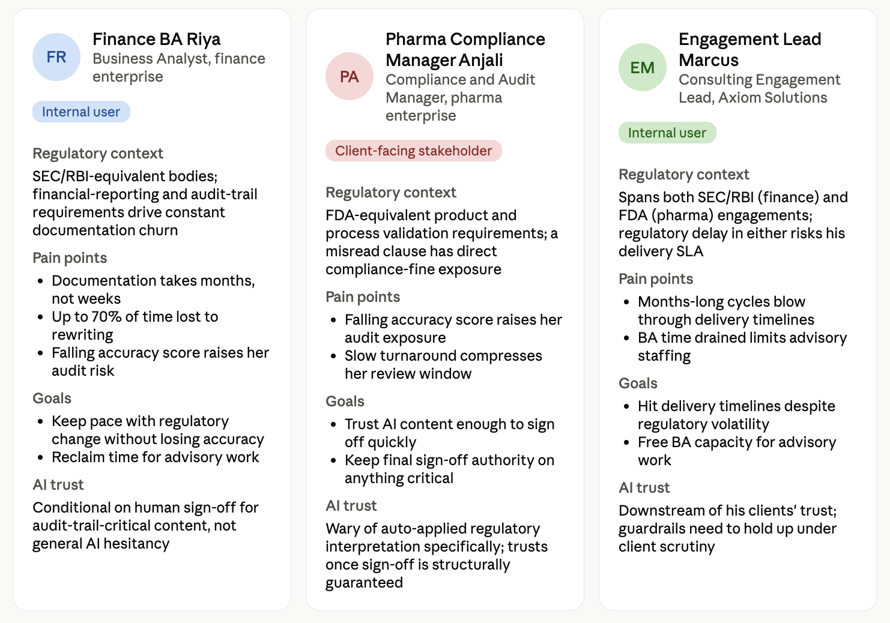

AI Prompt (Starter) - Survey Instrument

I am a Product manager looking to conduct a market survey for <AI Product Idea>
with a goal of truly understanding who our prospective customers are, their
preferences and what drives their purchase decisions.

Subsequently, I will use this survey results to translate into actionable
customer segments to determine market attractiveness.

A reference (anchor) set of 3 Personas from customer discovery is provided at
<Persona-1>, <Persona-2>, <Persona-3>

The survey should ask potential customers to rate the importance of key
attributes on a Likert Scale (1-7)
1 (Not at all important) to 7 (Extremely important)

Given that ProcessGenius operates in regulated industries (finance, pharma),
also include questions probing regulatory trust and human-oversight
expectations — not just speed and cost.

Act as a veteran market researcher.

Your Task is to provide me with 5 Key Survey Attributes to include in the survey.

Ask me any questions you have.

<AI Product Idea>
ProcessGenius AI — an intelligent Generative AI system within Axiom Solutions'
consulting offering that generates, updates, and audits compliance/process
documentation, translates complex regulatory clauses into plain language, and
flags compliance gaps for enterprise clients in regulated industries.
</AI Product Idea>

<Persona-1>
[Finance BA Fatima — full block from Step 1]
</Persona-1>

<Persona-2>
[Pharma Compliance Priya — full block from Step 1]
</Persona-2>

<Persona-3>
[Engagement Lead Ethan — full block from Step 1]
</Persona-3>

COSTARS Prompt — Survey Instrument

#### CONTEXT & OBJECTIVE
You are tasked with generating a complete, professional-grade survey instrument
that will be used to gather structured market research data for a
<AI_Product_Idea>.

The goal of this survey is to collect five types of information from potential
customers/stakeholders:
1. Firmographics (e.g., company size, sector, regulatory regime)
2. Current compliance documentation workload and cost
3. Purchase and feature preference insights
4. Regulatory trust & human-oversight expectations
5. Open-ended data for later cluster-analysis and segmentation

The survey must be structured using input from three specific personas
(provided), and formatted for immediate use in Google Forms.

#### STYLE
You are an expert market-research survey designer with over 20 years of
experience in B2B enterprise SaaS. You have deep domain expertise in crafting
surveys that are clear, unbiased, scalable, and formatted to feed directly into
analytical tools and segmentation models. Your deliverables are form-ready,
logically structured, and follow best practices for survey design — including
clear instructions, clean sectioning, and respondent-friendly formatting.

#### TONE
- Professional — suitable for compliance managers, BAs, and consulting leads
- Precise — clean, clear instructions and consistent formatting
- Respectful & inviting — encouraging honest input while maintaining efficiency

#### AUDIENCE
The survey will be taken by one of the following three personas, each
representing a different role and regulatory context:
<Persona-1>
<Persona-2>
<Persona-3>

They represent the target market for <AI_Product_Idea>

#### RESPONSE
Return a fully structured and formatted survey instrument for Google Forms.
Your output must include:
- Form Title and Intro Text
- 5 Clearly Separated Sections:
1. Section A: Firmographics
2. Section B: Current Compliance Documentation Workload
3. Section C: Feature Importance & Adoption Drivers
4. Section D: Regulatory Trust & Oversight Expectations
5. Section E: Open-Ended Insights

Each section should contain:
- A section heading
- A short instructional blurb
- Numbered questions
- The correct response type for Google Forms
(e.g., Dropdown, Short Answer, Paragraph Text, Linear Scale, Grid)

Each question must include:
- Exact wording
- Clearly listed options (if applicable)
- Proper scale descriptions where relevant

#### STEPS
1. Set Up the Form Header
- Title the form: <Survey_Form_Title>
- Add an intro message:
"Thank you for participating. Your responses are valuable in shaping how
our product serves your organization's compliance needs. All questions
are required and appreciated."

2. Build Section A: Firmographics
- Title: "Section A: About Your Organization"
- Instructions: "Tell us a little about your company and regulatory context."
- Include all firmographic questions from the input variables.

3. Build Section B: Current Compliance Documentation Workload
- Title: "Section B: Compliance Documentation Workload"
- Instructions: "Help us understand your current documentation process,
timelines, and spend."
- Include all workload questions from the input variables.

4. Build Section C: Feature Importance & Adoption Drivers
- Title: "Section C: Evaluating AI Features"
- Instructions: "Please rate the importance of each feature on a scale from
1 (Not at all important) to 7 (Extremely important)."
- Present feature statements as a Linear Scale Grid (1-7)
- Include all scale-based questions from the input variables.

5. Build Section D: Regulatory Trust & Oversight Expectations
- Title: "Section D: Trust & Oversight"
- Instructions: "Rate how important each safeguard is to your willingness to
adopt this tool, from 1 (Not at all important) to 7 (Extremely important)."
- Include all trust/oversight questions from the input variables.

6. Build Section E: Open-Ended Insights
- Title: "Section E: Your Insights"
- Instructions: "We'd like to hear from you in your own words."
- Include all open-ended questions from the input variables.

7. Ensure Output Is Form-Ready
- Maintain consistent formatting throughout
- Avoid ambiguous phrasing
- Make the full survey easy to import or recreate manually in Google Forms

### INPUT VARIABLES

<AI_Product_Idea>
ProcessGenius AI — an intelligent Generative AI system within Axiom Solutions'
consulting offering that generates, updates, and audits compliance/process
documentation, translates complex regulatory clauses into plain language, and
flags compliance gaps for enterprise clients in regulated industries.
</AI_Product_Idea>

<Analysis>
Customer segmentation with cluster-analysis.
</Analysis>

<Persona-1>
Finance BA Fatima — [full block from Step 1]
</Persona-1>

<Persona-2>
Pharma Compliance Priya — [full block from Step 1]
</Persona-2>

<Persona-3>
Engagement Lead Ethan — [full block from Step 1]
</Persona-3>

<Survey_Form_Title>
"ProcessGenius AI - Compliance Stakeholder Insight Survey"
</Survey_Form_Title>

### Survey Questions

#### Section A: Firmographics
Q1. What is your organization's approximate employee count?
- Type: Dropdown
- Options: "1,000–2,500", "2,501–5,000", "5,001–10,000", "10,000+"

Q2. Which regulatory regime primarily governs your compliance documentation?
- Type: Dropdown
- Options: "Finance (SEC/RBI-type)", "Pharmaceutical (FDA-type)", "Both", "Other"

Q3. What is your role in relation to compliance documentation?
- Type: Dropdown
- Options: "I produce it (e.g., Business Analyst)", "I sign off on it (e.g.,
Compliance/Audit Manager)", "I own client delivery for it (e.g., Engagement
Lead)"

#### Section B: Current Compliance Documentation Workload
Q4. On average, how long does it take to produce compliant process
documentation for a new process (in weeks)?
- Type: Short answer (numeric)

Q5. What percentage of your (or your team's) time is spent re-writing
documentation due to regulatory changes?
- Type: Short answer (numeric, %)

Q6. How would you rate your current documentation accuracy (self-assessed,
1–10)?
- Type: Short answer (numeric)

#### Section C: Feature Importance & Adoption Drivers
- Type: Linear-scale (1 = Not at all important, 7 = Extremely important)

Q7. "The AI must generate documentation that is compliant on first draft."
Q8. "Automatically flagging compliance gaps before an audit is important."
Q9. "The AI's ability to translate complex clauses into plain language for
non-technical stakeholders matters to me."
Q10. "Faster turnaround on documentation updates when regulations change is
important."
Q11. "Seamless integration with our existing workflow/documentation systems
matters."

#### Section D: Regulatory Trust & Oversight Expectations
- Type: Linear-scale (1 = Not at all important, 7 = Extremely important)

Q12. "Mandatory human sign-off on any AI-generated output before it reaches a
client or auditor is important to me."
Q13. "Clear labeling of which content is AI-generated versus human-verified is
important."
Q14. "A transparent track record of zero critical compliance
misinterpretations would influence my trust in this tool."

#### Section E: Open-Ended Insights
Q15. What is your primary concern about using AI for compliance documentation?
- Type: Paragraph text

Q16. Describe the biggest compliance-documentation-related pain point you face
today.
- Type: Paragraph text

